Survival Analysis of Lung Cancer Trial:

Veteran’s Administration

Introduction
A survival analysis was completed using the data from the Lung cancer trial. The dataset involved 137 patients with advanced, inoperable lung cancer. Patients were assigned to either a chemotherapy treatment (standard treatment) or a combination of chemotherapy and a new test drug (test treatment).

Patients were followed until they passed away (status dead), or may have dropped out of the study (status censored). Patients who were alive at the end of the study were also considered censored. The objective was to compare survival outcomes between treatment groups, and to examine how age and months from diagnosis affected patient survival.

Methodology
The analysis utilized the following methods:
- Kaplan-Meier curves - estimate survival probabilities over time and compare treatment groups.
- Semi-parametric models or Cox proportional hazards models - explore the relationship between covariates and survival. Covariates in this study included lung cancer cell type, prior months from diagnosis before participating in the study, age, and prior chemotherapy received or not.
- Parametric models - estimate survival under distributional assumptions and compare model fits. These models can account for covariates as well.

Analysis
Kaplan Meier curves were used to compare survival probabilities between patients receiving standard vs. test treatment.

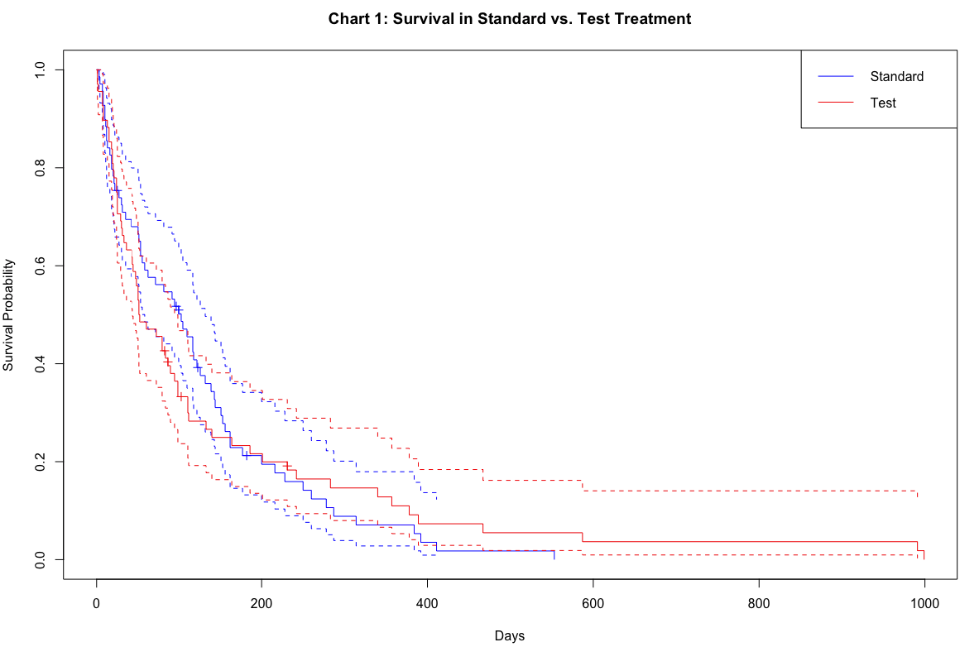

Chart 1 shows survival probabilities for each treatment type. The dashed lines are 95% confidence intervals. It may seem there may be differences in survival for standard vs. test treatment however, the differences were not statistically significant as indicated by the overlapping confidence intervals.
The curves did show a higher survival probability in the standard treatment group vs. the test treatment group during the initial days. As the days progressed, the test treatment group seemed to have a higher survival probability compared to the standard treatment groups. This seems to indicate that the effects of the new test drug may be low in the initial days and the effect increases as days progress.
Since patients treated with prior chemotherapy may have a better prognosis than patients not treated with prior chemotherapy, separate Kaplan Meier curves were also created for each of those groups. See Chart 2. The curves seemed to overlap across treatment and prior chemotherapy groups. Confidence intervals were not shown in Chart 2 to reduce clutter.
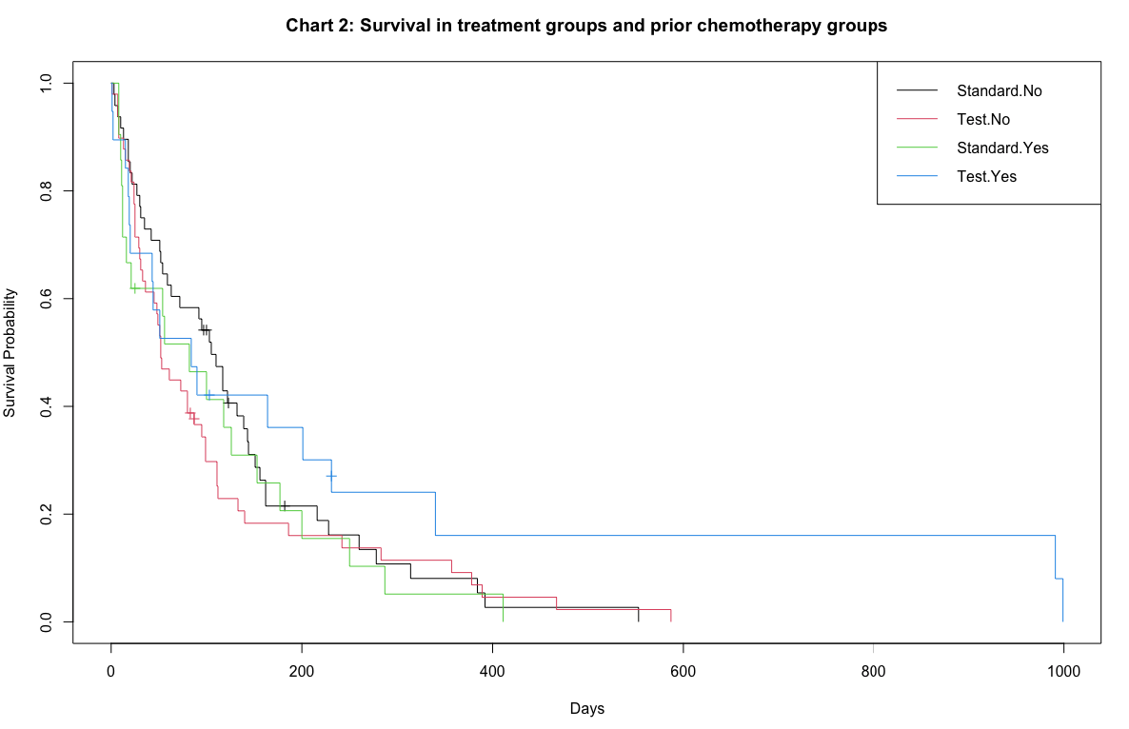
Chart 2 was further separated into different charts to show only patients with no prior chemotherapy or with prior chemotherapy. This helps to reduce clutter and provide a clear visualization. See Charts 3 and 4. Confidence intervals were included in these plots. Confidence intervals seemed to overlap, indicating no statistical significance between the standard vs. test treatment.
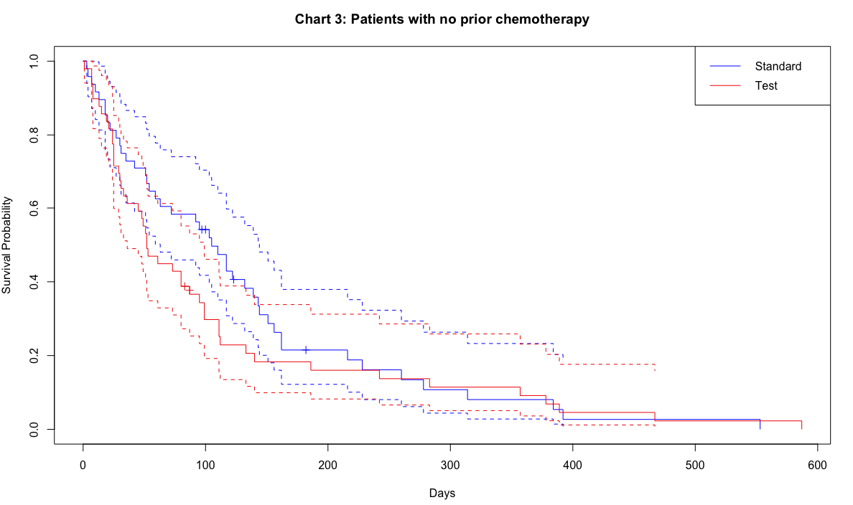 | 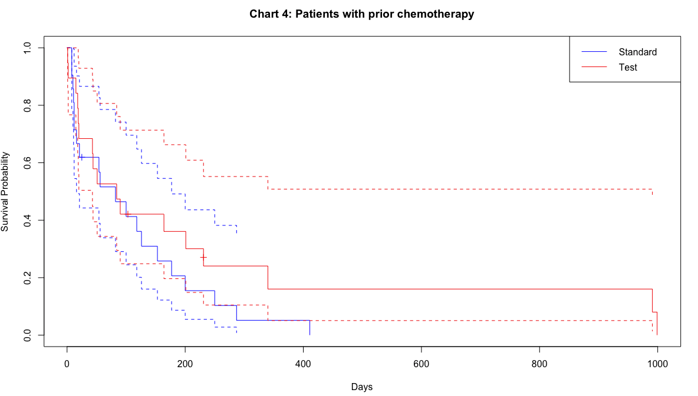

The treatments may have different survival results depending on the lung cancer cell type. The dataset may further be divided into patients with prior chemotherapy, and the cell type of lung cancer, however number of patients in each group was low. Creating Kaplan Meier curves from a low number of patients would make the results unreliable, hence these curves were not created.

The Kaplan-Meier curves were used to compare the survival probabilities of a patient at 6 months (183 days) and 1 year (365 days). The differences were not statistically significant.

 | 183 days | 365 days
Standard treatment all patients | 21.2% | 7.1%
Test treatment all patients | 23.3% | 11.0%
Standard treatment in patients with NO prior chemotherapy | 21.51% | 8.07%
Test treatment in patients with NO prior chemotherapy | 18.31% | 9.16%
Standard treatment in patients with prior chemotherapy | 20.63% | 5.16%
Test treatment IN patients with prior chemotherapy | 36.1% | 16.0%

The Kaplan-Meier curves were used to determine the mean survival days for a patient in the standard vs. test treatment groups. Restricted Mean Survival Times (RMST) were calculated as the average survival time up to the longest observed time in each group.

 | Mean - restricted | Highest Survival days
Standard treatment all patients | 124 | 999
Test treatment all patients | 142
Standard treatment in patients with NO prior chemotherapy | 131 | 587
Test treatment in patients with NO prior chemotherapy | 110
Standard treatment in patients with prior chemotherapy | 109 | 999
Test treatment yes patients with prior chemotherapy | 243

Semi-parametric models (Cox Proportional Hazards), and parametric models were created to estimate the effects of age and months of diagnosis on survival probabilities in patients with standard vs. test treatments.

The following effects were observed from Age using one of the Semi-parametric models:
- Standard treatment group:
  - Age seemed to decrease survival in patients with standard treatment. However, this effect was not statistically significant. P-value of 0.68. The hazard rate for standard treatment was 1.0051, confidence interval 95% (0.9810 – 1.030). Each additional year of age was associated with a 0.51% increase in the hazard of death.
- Test treatment:
  - Age seemed to increase survival in patients with test treatment. However, this effect was not statistically significant. P-value of 0.953. The hazard rate for test treatment was 0.9988, confidence interval 95% (0.9594 – 1.040) compared to standard treatment. Each additional year of age was associated with a 0.12% decrease in the hazard of death.

The following effects were observed from Months of diagnosis using one of the Semi-parametric models:
- Standard treatment:
  - As Months from diagnosis increased, it seemed to decrease survival. However, the effect was not significant, p-value of 0.44. The hazard rate was 1.013, CI (0.958 – 1.03). Each additional month of diagnosis was associated with a 1.3% increase in the hazard of death.
- Test treatment:
  - As Months from diagnosis increased, it seemed to increase survival. However, the effect was not significant, p-value of 0.81. The hazard rate was 0.9954, CI (0.958 – 1.034). Each additional month of diagnosis was associated with a 0.46% decrease in the hazard of death compared to the standard treatment group.

The following effects were observed from Age using one of the Parametric models:
- Standard treatment:
  - As age increased, it seemed to increase survival. However, the effect was not significant, p-value of 0.54. The hazard rate was 1.0075. Each additional year in age was associated with a 0.75% decrease in the hazard of death.
- Test treatment:
  - As age increased, it seemed to decrease survival. However, the effect was not significant, p-value of 0.93. The hazard rate was 0.998. Each additional year in age was associated with a 0.2% increase in the hazard of death.

The following effects were observed from Months from diagnosis using one of the Parametric models:
- Standard treatment:
  - As months from diagnosis increased, it seemed to increase survival. However, the effect was not significant, p-value of 0.49. The hazard rate was 1.012. Each additional month from diagnosis was associated with a 0.12% decrease in the hazard of death.
- Test treatment:
  - As months from diagnosis increased, it seemed to decrease survival. However, the effect was not significant, p-value of 0.9. The hazard rate was 0.998. Each additional year in months from diagnosis was associated with a 0.2% increase in the hazard of death.

Conclusion
Kaplan-Meier curves seemed to show modest differences in survival between standard vs. test treatment, but the differences were not statistically significant. The differences were not statistically significant, even if the patients were separated into groups of receiving prior chemotherapy or not. Cox and parametric models showed that Age and Months from diagnosis had no meaningful impact on survival, regardless of treatment.

Further investigation is recommended to explore the treatment effects for different lung cancer cell types. If possible, more lung cancer patients should be enrolled in the trial to obtain a large sample for each lung cancer subtype. This analysis did not seem to provide evidence of survival benefits in lung cancer patients treated with the test drug.

References
- Datalab – Kaplan Meier Curve. https://datatab.net/tutorial/kaplan-meier-curve
- STHDA – Cox proportional hazards model. https://www.sthda.com/english/wiki/cox-proportional-hazards-model#:~:text=Cox%20regression%20model.-,Basics%20of%20the%20Cox%20proportional%20hazards%20model,in%20the%20survival%2Danalysis%20literature.&text=where%2C,...%2Cxp)
- Parametric survival modeling - https://devinincerti.com/2019/06/18/parametric_survival.html

